PSP [20ES104] COURSE PROJECT REPORT
On
Resort room management
************************************************************************************
****************
By
V. Shiva chaithanya (2203A52060)

Under the guidance of
Mr. Srinivas Aluvala, M.Tech. (Ph.D)
Assistant Professor

Department of CSE


Submitted to
Department Computer Science and Artificial Intelligence SR University
Ananthasagar(V), Hasanparthy(M), Hanamkonda(Dist.) – 506371 www.sru.edu.in
June 2023

Department of Computer Science and Artificial Intelligence

CERTIFICATE

This is to certify that the PSP course project report entitled “Resort room management ” is a record of bonafide work carried out by the student bearing roll number(s) 2203A52060 of Computer Science and Artificial Intelligence department during the academic year 2022-23.

Supervisor
(Srinivas Aluvala)

INDEX

Sl. No Title Page No.
- Problem statement 1
- Module-wise description 2
- Knowledge required to develop the project 4
- Source code (.c file code followed by .h file code) 5
- Results 35

PROBLEM STATEMENT:

develop a C Application to store details of the resort’s reservation
in terms of (name,age,date of birth,number of days,room number,
nationality ,phone number,etc..) store the data and print them.

Provide the functionality for below mentioned:
- Read ‘n’ family members details.
- Sort ‘n’ family’ details according to:
  - Name
  - Age
  - Aadhar No
  - Birth
  - Room number
  - Phone number
  - Date incomming
  - Date of exit
  - Number of days
- Search ‘n’ family details according to:

  - Name
  - Age
  - Aadhar No
  - Birth
  - Room number
  - Phone number
  - Date incomming
  - Date of exit
  - Number of days

4.print ‘n’ family details.

MODULES:

In this application all variables and structure are declared globally so that these variables and structure members can be accessed throughout the program at any function call. We can choose any function by using function calls which are declared in switch-case. In order to repeat the loop control statement (do-while) is used with condition. The memory allocation will be done in this program dynamically. The application asks the person who runs the program that how many passengers data he/she want to store.
In this application four modules are used.

- Read/Input
In this module the application asks the person who runs the program to enter n passenger’s details. To give n customers details for loop is used.
- Sorting

In this module sorting of data is done according to the chosen wise.

In this module there is a sub menu which asks to select the sorting wise by using switch case. The sorting sub menu will be like press 1 to sort by name wise press 2 to sort by age wise press 3 to sort aadhar number wise press 4 to sort by berth wise 5 to sort by date of travel wise press 6 to sort by train wise press 6 to sort train name wise press 7 to sort by boarding station wise press 8 to sort departing station wise.
In this module we used another control statement (do while) so that the application asks whether to continue sorting.
3.Searching
In this module searching of data is done according to the chosen wise.
In this module there is a sub menu which asks to select the sorting wise by using switch case. The sorting sub menu will be like press 1 to search by name wise press
2 to search by age wise press 3 to search aadhar number wise press 4 to search by berth wise 5 to search by date of travel wise press 6 to search by train wise press 6 to search train name wise press 7 to
search by boarding station wise press 8 to search departing station wise.

In this module we used another control statement (do while) so that the application asks whether to continue searching.
- Print
In this module all the stored details of n customers will be displayed on to the screen. In this module printf function and for loop are used.

KNOWLEDGE REQUIRED TO DEVELOP THIS APPLICATION
  - Control Statements (if, if-else, switch)

  - Loop Statements (while/do while, for)

  - Arrays (1D/2D-arrays)

  - Strings (Strings and Table of strings) and its functions (strcpy, strcmp)
  - Functions (Any type of user defined functions)

  - Structure (structures and nested structures)

  - Pointers (pointer to strings and pointers to structures)

  - Dynamic Memory Allocation (malloc/ calloc/ realloc)

Source code:
#include<stdio.h>
#include<stdlib.h>
#include<time.h>
void add(); //FUNCTIONS
void list();
void edit();
void delete1();
void search();
void login()
{
int a=0,i=0;
char uname[10],c=' ';
char pword[10],code[10];
char user[10]="user";
char pass[10]="pass";
do
{
system("cls");

printf("\n ********* LOGIN FORM ********* ");
printf(" \n ENTER USERNAME:-");
scanf("%s", &uname);
printf(" \n ENTER PASSWORD:-");
while(i<10)
{
pword[i]=getch();
c=pword[i];
if(c==13) break;
else printf("*");
i++;
}
pword[i]='\0';
i=0;
if(strcmp(uname,user)==0 && strcmp(pword,pass)==0)
{
printf(" \n\n\n WELCOME !!!! LOGIN IS SUCCESSFUL");

break;
}
else
{
printf("\n SORRY !!!! LOGIN IS UNSUCESSFUL");
a++;

getch();

}
}
while(a<=2);
if (a>2)
{
printf("\nSorry you have entered the wrong username and password for four times!!!");

getch();

}
system("cls");
}

struct CustomerDetails //STRUCTURE DECLARATION
{
char roomnumber[10];
char name[20];
int amount[30];
char address[25];
char phonenumber[15];
char nationality[15];
char email[20];
char period[10];
char arrivaldate[10];
}s;

int main(){ // MAIN FUNCTION
int i=0;

time_t t;
time(&t);
char customername;
char choice;

system("cls"); // FOR CLEARING SCREEN
printf(" --------------------------------------------------------------------------\n");
printf("| |\n");
printf("| |\n");
printf("| OOOOOO OOOOOO OOOOOO OOOOOO OOOOOO OOOOOO O O OOOOOOO OOOOOO |\n");
printf("| O O O O O O O O O O O O |\n");
printf("| O OOOOO OOOOOO OOOOO OOOOO O O O O O O OOOOO OOOOOO |\n");
printf("| O O O O O O O O O O O O O O |\n");
printf("| OOOOOO O O OOOOOO OOOOOO O OOOOOO O O O OOOOOO OOOOOO |\n");
printf("| |\n");
printf("---------------------------------------------------------------------------\n");
printf("\t\t************************************************\n");
printf("\t\t* *\n");
printf("\t\t* ----------------------------- *\n");
printf("\t\t* WELCOME TO C.V RESORT *\n");
printf("\t\t* ----------------------------- *\n");
printf("\t\t* *\n");
printf("\t\t* *\n");
printf("\t\t* Brought To you by SHIVA CHAITHANYA *\n");
printf("\t\t* *\n");
printf("\t\t* CONTACT US:7671833869 *\n");
printf("\t\t************************************************\n");
printf("\t \n");
for(i=0;i<80;i++)
printf("-");
printf("\nCurrent date and time : %s",ctime(&t));
for(i=0;i<80;i++)
printf("-");
printf(" \n Press any key to continue:");

getch();
system("cls");
login();
system("cls");
while (1) // INFINITE LOOP
{
system("cls");
for(i=0;i<80;i++)
printf("-");
printf("\n");
printf(" C.V's resort \n");
printf(" \n");
for(i=0;i<80;i++)
printf("-");
printf("\n");
printf("\t\t Please enter your choice for menu:");
printf("\n\n");
printf(" \n Enter 1 -> Book a room");
printf("\n------------------------");
printf(" \n Enter 2 -> View Customer Record");
printf("\n----------------------------------");
printf(" \n Enter 3 -> Delete Customer Record");
printf("\n-----------------------------------");
printf(" \n Enter 4 -> Search Customer Record");
printf("\n-----------------------------------");
printf(" \n Enter 5 -> Edit Record");
printf("\n-----------------------");
printf(" \n Enter 6 -> Exit");
printf("\n-----------------");
printf("\n");
for(i=0;i<80;i++)
printf("-");
printf("\nCurrent date and time : %s",ctime(&t));
for(i=0;i<80;i++)
printf("-");
choice=getche();
choice=toupper(choice);
switch(choice) // SWITCH STATEMENT
{
case '1':
add();break;
case '2':
list();break;
case '3':
delete1();break;
case '4':
search();break;
case '5':
edit();break;
case '6':
system("cls");
printf("\n\n\t **THANK YOU**");
printf("\n\t FOR TRUSTING OUR SERVICE");
exit(0);
break;
default:
system("cls");
printf("Incorrect Input");
printf("\n Press any key to continue");
getch();
}
}
}
void add()
{
FILE *f;
char test;
f=fopen("add.txt","a+");
if(f==0)
{ f=fopen("add.txt","w+");
system("cls");
printf("Please hold on while we set our database in your computer!!");
printf("\n Process completed press any key to continue!! ");
getch();
}
while(1)
{
system("cls");
printf("\n Enter Customer Details:");
printf("\n**********");
printf("\n Enter Room number:\n");
scanf("\n%s",s.roomnumber);
fflush(stdin);
printf("Enter Name:\n");
scanf("%s",s.name);
printf("Enter Address:\n");
scanf("%s",s.address);
printf("Enter Phone Number:\n");
scanf("%s",s.phonenumber);
printf("Enter Nationality:\n");
scanf("%s",s.nationality);
printf("Enter Email:\n");
scanf(" %s",s.email);
printf("Enter Period(\'x\'days):\n");
scanf("%s",&s.period);
printf("Enter Arrival date(dd\\mm\\yyyy):\n");
scanf("%s",&s.arrivaldate);
fwrite(&s,sizeof(s),1,f);
fflush(stdin);
printf("\n\n1 Room is successfully booked!!");
printf("\n Press esc key to exit, any other key to add another customer detail:");
test=getche();
if(test==27)
break;
}
fclose(f);
}
void list()
{
FILE *f;
int i;
if((f=fopen("add.txt","r"))==NULL)
exit(0);
system("cls");
printf("ROOM ");
printf("NAME\t ");
printf("\tADDRESS ");
printf("\tPHONENUMBER ");
printf("\tNATIONALITY ");
printf("\tEMAIL ");
printf("\t\t PERIOD ");
printf("\t ARRIVALDATE \n");

for(i=0;i<118;i++)
printf("-");
while(fread(&s,sizeof(s),1,f)==1)
{
printf("\n%s\t%s \t\t%s\t\t%s\t%s\t\t%s \t\%s\t%s",s.roomnumber, s.name , s.address , s.phonenumber ,s.nationality ,s.email,s.period, s.arrivaldate);
}
printf("\n");
for(i=0;i<118;i++)
printf("-");

fclose(f);
getch();
}
void delete1()
{
FILE *f,*t;
int i=1;
char roomnumber[20];
if((t=fopen("temp.txt","w"))==NULL)
exit(0);
if((f=fopen("add.txt","r"))==NULL)
exit(0);
system("cls");
printf("Enter the Room Number of the hotel to be deleted from the database: \n");
fflush(stdin);
scanf("%s",roomnumber);
while(fread(&s,sizeof(s),1,f)==1)
{
if(strcmp(s.roomnumber,roomnumber)==0)
{ i=0;
continue;
}
else
fwrite(&s,sizeof(s),1,t);
}
if(i==1)
{
printf("\n\n Records of Customer in this Room number is not found!!");
getch();
fclose(f);
fclose(t);
main();
}
fclose(f);
fclose(t);
remove("add.txt");
rename("temp.txt","add.txt");
printf("\n\nThe Customer is successfully removed....");
fclose(f);
fclose(t);
getch();
}
void search()
{
system("cls");
FILE *f;
char roomnumber[20];
int flag=1;
f=fopen("add.txt","r+");
if(f==0)
exit(0);
fflush(stdin);
printf("Enter Room number of the customer to search its details: \n");
scanf("%s", roomnumber);
while(fread(&s,sizeof(s),1,f)==1)
{
if(strcmp(s.roomnumber,roomnumber)==0){
flag=0;
printf("\n\tRecord Found\n ");
printf("\nRoom Number:\t%s",s.roomnumber);
printf("\nName:\t%s",s.name);
printf("\nAddress:\t%s",s.address);
printf("\nPhone number:\t%s",s.phonenumber);
printf("\nNationality:\t%s",s.nationality);
printf("\nEmail:\t%s",s.email);
printf("\nPeriod:\t%s",s.period);
printf("\nArrival date:\t%s",s.arrivaldate);
flag=0;
break;
}
}
if(flag==1){
printf("\n\tRequested Customer could not be found!");
}
getch();
fclose(f);
}
void edit()
{
FILE *f;
int k=1;
char roomnumber[20];
long int size=sizeof(s);
if((f=fopen("add.txt","r+"))==NULL)
exit(0);
system("cls");
printf("Enter Room number of the customer to edit:\n\n");
scanf("%[^\n]",roomnumber);
fflush(stdin);
while(fread(&s,sizeof(s),1,f)==1)
{
if(strcmp(s.roomnumber,roomnumber)==0)
{
k=0;
printf("\nEnter Room Number :");
gets(s.roomnumber);
printf("\nEnter Name :");
fflush(stdin);
scanf("%s",&s.name);
printf("\nEnter Address :");
scanf("%s",&s.address);
printf("\nEnter Phone number :");
scanf("%f",&s.phonenumber);
printf("\nEnter Nationality :");
scanf("%s",&s.nationality);
printf("\nEnter Email :");
scanf("%s",&s.email);
printf("\nEnter Period :");
scanf("%s",&s.period);
printf("\nEnter Arrival date :");
scanf("%s",&s.arrivaldate);
fseek(f,size,SEEK_CUR);
fwrite(&s,sizeof(s),1,f);
break;
}
}
if(k==1){
printf("\n\nTHE RECORD DOESN'T EXIST!!!!");
fclose(f);
getch();

}else{
fclose(f);
printf("\n\n\t\tYOUR RECORD IS SUCCESSFULLY EDITED!!!");
getch();
}

}

SOURCE CODE [HEADER FILE]:

#include<stdio.h>
#ifndef _STDIO_H
#define _STDIO_H 1
#define __GLIBC_INTERNAL_STARTING_HEADER_IMPLEMENTATION
#include <bits/libc-header-start.h>
__BEGIN_DECLS
#define __need_size_t
#define __need_NULL
#include <stddef.h>
#define __need___va_list
#include <stdarg.h>
#include <bits/types.h>
#include <bits/types/__fpos_t.h>
#include <bits/types/__fpos64_t.h>
#include <bits/types/__FILE.h>
#include <bits/types/FILE.h>
#include <bits/types/struct_FILE.h>
#ifdef __USE_GNU
# include <bits/types/cookie_io_functions_t.h>
#endif
#if defined __USE_XOPEN || defined __USE_XOPEN2K8
# ifdef __GNUC__
# ifndef _VA_LIST_DEFINED
typedef __gnuc_va_list va_list;
# define _VA_LIST_DEFINED
# endif
# else
# include <stdarg.h>
# endif
#endif
#if defined __USE_UNIX98 || defined __USE_XOPEN2K
# ifndef __off_t_defined
# ifndef __USE_FILE_OFFSET64
typedef __off_t off_t;
# else
typedef __off64_t off_t;
# endif
# define __off_t_defined
# endif
# if defined __USE_LARGEFILE64 && !defined __off64_t_defined
typedef __off64_t off64_t;
# define __off64_t_defined
# endif
#endif
#ifdef __USE_XOPEN2K8
# ifndef __ssize_t_defined
typedef __ssize_t ssize_t;
# define __ssize_t_defined
# endif
#endif
#ifndef __USE_FILE_OFFSET64
typedef __fpos_t fpos_t;
#else
typedef __fpos64_t fpos_t;
#endif
#ifdef __USE_LARGEFILE64
typedef __fpos64_t fpos64_t;
#endif
#define _IOFBF 0 /* Fully buffered. */
#define _IOLBF 1 /* Line buffered. */
#define _IONBF 2 /* No buffering. */
#define BUFSIZ 8192
#define EOF (-1)
#define SEEK_SET 0 /* Seek from beginning of file. */
#define SEEK_CUR 1 /* Seek from current position. */
#define SEEK_END 2 /* Seek from end of file. */
#ifdef __USE_GNU
# define SEEK_DATA 3 /* Seek to next data. */
# define SEEK_HOLE 4 /* Seek to next hole. */
#endif
#if defined __USE_MISC || defined __USE_XOPEN
# define P_tmpdir "/tmp"
#endif
#include <bits/stdio_lim.h>
#if __GLIBC_USE (ISOC2X)
# define _PRINTF_NAN_LEN_MAX 4
#endif
extern FILE *stdin; /* Standard input stream. */
extern FILE *stdout; /* Standard output stream. */
extern FILE *stderr; /* Standard error output stream. */
#define stdin stdin
#define stdout stdout
#define stderr stderr
extern int remove (const char *__filename) __THROW;
extern int rename (const char *__old, const char *__new) __THROW;
#ifdef __USE_ATFILE
extern int renameat (int __oldfd, const char *__old, int __newfd,
const char *__new) __THROW;
#endif
#ifdef __USE_GNU
# define RENAME_NOREPLACE (1 << 0)
# define RENAME_EXCHANGE (1 << 1)
# define RENAME_WHITEOUT (1 << 2)
extern int renameat2 (int __oldfd, const char *__old, int __newfd,
const char *__new, unsigned int __flags) __THROW;
#endif
extern int fclose (FILE *__stream);
#undef __attr_dealloc_fclose
#define __attr_dealloc_fclose __attr_dealloc (fclose, 1)
#ifndef __USE_FILE_OFFSET64
extern FILE *tmpfile (void)
__attribute_malloc__ __attr_dealloc_fclose __wur;
#else
# ifdef __REDIRECT
extern FILE *__REDIRECT (tmpfile, (void), tmpfile64)
__attribute_malloc__ __attr_dealloc_fclose __wur;
# else
# define tmpfile tmpfile64
# endif
#endif
#ifdef __USE_LARGEFILE64
extern FILE *tmpfile64 (void)
__attribute_malloc__ __attr_dealloc_fclose __wur;
#endif
extern char *tmpnam (char[L_tmpnam]) __THROW __wur;
#ifdef __USE_MISC
extern char *tmpnam_r (char __s[L_tmpnam]) __THROW __wur;
#endif
#if defined __USE_MISC || defined __USE_XOPEN
extern char *tempnam (const char *__dir, const char *__pfx)
__THROW __attribute_malloc__ __wur __attr_dealloc_free;
#endif
extern int fflush (FILE *__stream);
#ifdef __USE_MISC
extern int fflush_unlocked (FILE *__stream);
#endif
#ifdef __USE_GNU
extern int fcloseall (void);
#endif
#ifndef __USE_FILE_OFFSET64
extern FILE *fopen (const char *__restrict __filename,
const char *__restrict __modes)
__attribute_malloc__ __attr_dealloc_fclose __wur;
extern FILE *freopen (const char *__restrict __filename,
const char *__restrict __modes,
FILE *__restrict __stream) __wur;
#else
# ifdef __REDIRECT
extern FILE *__REDIRECT (fopen, (const char *__restrict __filename,
const char *__restrict __modes), fopen64)
__attribute_malloc__ __attr_dealloc_fclose __wur;
extern FILE *__REDIRECT (freopen, (const char *__restrict __filename,

const char *__restrict __modes,
FILE *__restrict __stream), freopen64)
__wur;
# else
# define fopen fopen64
# define freopen freopen64
# endif
#endif
#ifdef __USE_LARGEFILE64
extern FILE *fopen64 (const char *__restrict __filename,
const char *__restrict __modes)
__attribute_malloc__ __attr_dealloc_fclose __wur;
extern FILE *freopen64 (const char *__restrict __filename,
const char *__restrict __modes,
FILE *__restrict __stream) __wur;
#endif
#ifdef __USE_POSIX
extern FILE *fdopen (int __fd, const char *__modes) __THROW
__attribute_malloc__ __attr_dealloc_fclose __wur;
#endif
#ifdef __USE_GNU
extern FILE *fopencookie (void *__restrict __magic_cookie,
const char *__restrict __modes,
cookie_io_functions_t __io_funcs) __THROW
__attribute_malloc__ __attr_dealloc_fclose __wur;
#endif
#if defined __USE_XOPEN2K8 || __GLIBC_USE (LIB_EXT2)
extern FILE *fmemopen (void *__s, size_t __len, const char *__modes)
__THROW __attribute_malloc__ __attr_dealloc_fclose __wur;
extern FILE *open_memstream (char **__bufloc, size_t *__sizeloc) __THROW
__attribute_malloc__ __attr_dealloc_fclose __wur;
#ifdef _WCHAR_H
extern __FILE *open_wmemstream (wchar_t **__bufloc, size_t *__sizeloc) __THROW
__attribute_malloc__ __attr_dealloc_fclose;
# endif
#endif
extern void setbuf (FILE *__restrict __stream, char *__restrict __buf) __THROW;
extern int setvbuf (FILE *__restrict __stream, char *__restrict __buf,
int __modes, size_t __n) __THROW;
#ifdef __USE_MISC
extern void setbuffer (FILE *__restrict __stream, char *__restrict __buf,
size_t __size) __THROW;
extern void setlinebuf (FILE *__stream) __THROW;
#endif
This function is a possible cancellation point and therefore not
marked with __THROW. */
extern int fprintf (FILE *__restrict __stream,
const char *__restrict __format, ...);
extern int printf (const char *__restrict __format, ...);
extern int sprintf (char *__restrict __s,
const char *__restrict __format, ...) __THROWNL;
extern int vfprintf (FILE *__restrict __s, const char *__restrict __format,
__gnuc_va_list __arg);
extern int vprintf (const char *__restrict __format, __gnuc_va_list __arg);
extern int vsprintf (char *__restrict __s, const char *__restrict __format,
__gnuc_va_list __arg) __THROWNL;
#if defined __USE_ISOC99 || defined __USE_UNIX98
extern int snprintf (char *__restrict __s, size_t __maxlen,
const char *__restrict __format, ...)
__THROWNL __attribute__ ((__format__ (__printf__, 3, 4)));
extern int vsnprintf (char *__restrict __s, size_t __maxlen,
const char *__restrict __format, __gnuc_va_list __arg)
__THROWNL __attribute__ ((__format__ (__printf__, 3, 0)));
#endif
#if __GLIBC_USE (LIB_EXT2)
extern int vasprintf (char **__restrict __ptr, const char *__restrict __f,
__gnuc_va_list __arg)
__THROWNL __attribute__ ((__format__ (__printf__, 2, 0))) __wur;
extern int __asprintf (char **__restrict __ptr,
const char *__restrict __fmt, ...)
__THROWNL __attribute__ ((__format__ (__printf__, 2, 3))) __wur;
extern int asprintf (char **__restrict __ptr,
const char *__restrict __fmt, ...)

__THROWNL __attribute__ ((__format__ (__printf__, 2, 3))) __wur;
#endif
#ifdef __USE_XOPEN2K8
extern int vdprintf (int __fd, const char *__restrict __fmt,
__gnuc_va_list __arg)
__attribute__ ((__format__ (__printf__, 2, 0)));
extern int dprintf (int __fd, const char *__restrict __fmt, ...)
__attribute__ ((__format__ (__printf__, 2, 3)));
#endif
extern int fscanf (FILE *__restrict __stream,
const char *__restrict __format, ...) __wur;
extern int scanf (const char *__restrict __format, ...) __wur;
extern int sscanf (const char *__restrict __s,
const char *__restrict __format, ...) __THROW;
#include <bits/floatn.h>
#if !__GLIBC_USE (DEPRECATED_SCANF) && !defined __LDBL_COMPAT \
&& __LDOUBLE_REDIRECTS_TO_FLOAT128_ABI == 0
# ifdef __REDIRECT
extern int __REDIRECT (fscanf, (FILE *__restrict __stream,
const char *__restrict __format, ...),
__isoc99_fscanf) __wur;
extern int __REDIRECT (scanf, (const char *__restrict __format, ...),
__isoc99_scanf) __wur;
extern int __REDIRECT_NTH (sscanf, (const char *__restrict __s,
const char *__restrict __format, ...),
__isoc99_sscanf);
# else
extern int __isoc99_fscanf (FILE *__restrict __stream,
const char *__restrict __format, ...) __wur;
extern int __isoc99_scanf (const char *__restrict __format, ...) __wur;
extern int __isoc99_sscanf (const char *__restrict __s,
const char *__restrict __format, ...) __THROW;
# define fscanf __isoc99_fscanf
# define scanf __isoc99_scanf
# define sscanf __isoc99_sscanf
# endif
#endif
#ifdef __USE_ISOC99
extern int vfscanf (FILE *__restrict __s, const char *__restrict __format,
__gnuc_va_list __arg)
__attribute__ ((__format__ (__scanf__, 2, 0))) __wur;
extern int vscanf (const char *__restrict __format, __gnuc_va_list __arg)
__attribute__ ((__format__ (__scanf__, 1, 0))) __wur;
extern int vsscanf (const char *__restrict __s,
const char *__restrict __format, __gnuc_va_list __arg)
__THROW __attribute__ ((__format__ (__scanf__, 2, 0)));
# if !__GLIBC_USE (DEPRECATED_SCANF)
# if defined __REDIRECT && !defined __LDBL_COMPAT \
&& __LDOUBLE_REDIRECTS_TO_FLOAT128_ABI == 0
extern int __REDIRECT (vfscanf,
(FILE *__restrict __s,
const char *__restrict __format, __gnuc_va_list __arg),
__isoc99_vfscanf)
__attribute__ ((__format__ (__scanf__, 2, 0))) __wur;
extern int __REDIRECT (vscanf, (const char *__restrict __format,
__gnuc_va_list __arg), __isoc99_vscanf)
__attribute__ ((__format__ (__scanf__, 1, 0))) __wur;
extern int __REDIRECT_NTH (vsscanf,
(const char *__restrict __s,
const char *__restrict __format,
__gnuc_va_list __arg), __isoc99_vsscanf)
__attribute__ ((__format__ (__scanf__, 2, 0)));
# elif !defined __REDIRECT
extern int __isoc99_vfscanf (FILE *__restrict __s,
const char *__restrict __format,
__gnuc_va_list __arg) __wur;
extern int __isoc99_vscanf (const char *__restrict __format,
__gnuc_va_list __arg) __wur;
extern int __isoc99_vsscanf (const char *__restrict __s,
const char *__restrict __format,
__gnuc_va_list __arg) __THROW;
# define vfscanf __isoc99_vfscanf
# define vscanf __isoc99_vscanf

# define vsscanf __isoc99_vsscanf
# endif
# endif
#endif /* Use ISO C9x. */
extern int fgetc (FILE *__stream);
extern int getc (FILE *__stream);
extern int getchar (void);
#ifdef __USE_POSIX199506
extern int getc_unlocked (FILE *__stream);
extern int getchar_unlocked (void);
#endif /* Use POSIX. */
#ifdef __USE_MISC
extern int fgetc_unlocked (FILE *__stream);
#endif /* Use MISC.
extern int fputc (int __c, FILE *__stream);
extern int putc (int __c, FILE *__stream);
extern int putchar (int __c);
#ifdef __USE_MISC
extern int fputc_unlocked (int __c, FILE *__stream);
#endif /* Use MISC. */
#ifdef __USE_POSIX199506
extern int putc_unlocked (int __c, FILE *__stream);
extern int putchar_unlocked (int __c);
#endif /* Use POSIX. */
#if defined __USE_MISC \
|| (defined __USE_XOPEN && !defined __USE_XOPEN2K)
extern int getw (FILE *__stream);
extern int putw (int __w, FILE *__stream);
#endif
extern char *fgets (char *__restrict __s, int __n, FILE *__restrict __stream)
__wur __fortified_attr_access (__write_only__, 1, 2);
#if __GLIBC_USE (DEPRECATED_GETS)
extern char *gets (char *__s) __wur __attribute_deprecated__;
#endif
#ifdef __USE_GNU
extern char *fgets_unlocked (char *__restrict __s, int __n,

FILE *__restrict __stream) __wur
__fortified_attr_access (__write_only__, 1, 2);
#endif
#if defined __USE_XOPEN2K8 || __GLIBC_USE (LIB_EXT2)
extern __ssize_t __getdelim (char **__restrict __lineptr,
size_t *__restrict __n, int __delimiter,
FILE *__restrict __stream) __wur;
extern __ssize_t getdelim (char **__restrict __lineptr,
size_t *__restrict __n, int __delimiter,
FILE *__restrict __stream) __wur;
extern __ssize_t getline (char **__restrict __lineptr,
size_t *__restrict __n,
FILE *__restrict __stream) __wur;
#endif
extern int fputs (const char *__restrict __s, FILE *__restrict __stream);
extern int puts (const char *__s);
extern int ungetc (int __c, FILE *__stream);
extern size_t fread (void *__restrict __ptr, size_t __size,
size_t __n, FILE *__restrict __stream) __wur;
extern size_t fwrite (const void *__restrict __ptr, size_t __size,
size_t __n, FILE *__restrict __s);
#ifdef __USE_GNU
extern int fputs_unlocked (const char *__restrict __s,
FILE *__restrict __stream);
#endif
#ifdef __USE_MISC
extern size_t fread_unlocked (void *__restrict __ptr, size_t __size,
size_t __n, FILE *__restrict __stream) __wur;
extern size_t fwrite_unlocked (const void *__restrict __ptr, size_t __size,
size_t __n, FILE *__restrict __stream);
#endif
extern int fseek (FILE *__stream, long int __off, int __whence);
extern long int ftell (FILE *__stream) __wur;
extern void rewind (FILE *__stream);
#if defined __USE_LARGEFILE || defined __USE_XOPEN2K
# ifndef __USE_FILE_OFFSET64

extern int fseeko (FILE *__stream, __off_t __off, int __whence);
extern __off_t ftello (FILE *__stream) __wur;
# else
# ifdef __REDIRECT
extern int __REDIRECT (fseeko,
(FILE *__stream, __off64_t __off, int __whence),
fseeko64);
extern __off64_t __REDIRECT (ftello, (FILE *__stream), ftello64);
# else
# define fseeko fseeko64
# define ftello ftello64
# endif
# endif
#endif
#ifndef __USE_FILE_OFFSET64

extern int fgetpos (FILE *__restrict __stream, fpos_t *__restrict __pos);
extern int fsetpos (FILE *__stream, const fpos_t *__pos);
#else
# ifdef __REDIRECT
extern int __REDIRECT (fgetpos, (FILE *__restrict __stream,
fpos_t *__restrict __pos), fgetpos64);
extern int __REDIRECT (fsetpos,
(FILE *__stream, const fpos_t *__pos), fsetpos64);
# else
# define fgetpos fgetpos64
# define fsetpos fsetpos64
# endif
#endif
#ifdef __USE_LARGEFILE64
extern int fseeko64 (FILE *__stream, __off64_t __off, int __whence);
extern __off64_t ftello64 (FILE *__stream) __wur;
extern int fgetpos64 (FILE *__restrict __stream, fpos64_t *__restrict __pos);
extern int fsetpos64 (FILE *__stream, const fpos64_t *__pos);
#endif
extern void clearerr (FILE *__stream) __THROW;

extern int feof (FILE *__stream) __THROW __wur;
extern int ferror (FILE *__stream) __THROW __wur;
#ifdef __USE_MISC
extern void clearerr_unlocked (FILE *__stream) __THROW;
extern int feof_unlocked (FILE *__stream) __THROW __wur;
extern int ferror_unlocked (FILE *__stream) __THROW __wur;
#endif
extern void perror (const char *__s);
#ifdef __USE_POSIX
extern int fileno (FILE *__stream) __THROW __wur;
#endif /* Use POSIX. */
#ifdef __USE_MISC
extern int fileno_unlocked (FILE *__stream) __THROW __wur;
#endif
#ifdef __USE_POSIX2
extern int pclose (FILE *__stream);
extern FILE *popen (const char *__command, const char *__modes)
__attribute_malloc__ __attr_dealloc (pclose, 1) __wur;
#endif
#ifdef __USE_POSIX
extern char *ctermid (char *__s) __THROW
__attr_access ((__write_only__, 1));
#endif /* Use POSIX. */
#if (defined __USE_XOPEN && !defined __USE_XOPEN2K) || defined __USE_GNU
extern char *cuserid (char *__s)
__attr_access ((__write_only__, 1));
#endif /* Use X/Open, but not issue 6. */
#ifdef __USE_GNU
struct obstack; /* See <obstack.h>. */
extern int obstack_printf (struct obstack *__restrict __obstack,
const char *__restrict __format, ...)
__THROWNL __attribute__ ((__format__ (__printf__, 2, 3)));
extern int obstack_vprintf (struct obstack *__restrict __obstack,
const char *__restrict __format,
__gnuc_va_list __args)
__THROWNL __attribute__ ((__format__ (__printf__, 2, 0)));

#endif /* Use GNU. */
#ifdef __USE_POSIX199506
extern void flockfile (FILE *__stream) __THROW;
extern int ftrylockfile (FILE *__stream) __THROW __wur;
extern void funlockfile (FILE *__stream) __THROW;
#endif /* POSIX */
#if defined __USE_XOPEN && !defined __USE_XOPEN2K && !defined __USE_GNU
# include <bits/getopt_posix.h>
#endif
/* Slow-path routines used by the optimized inline functions in
bits/stdio.h. */
extern int __uflow (FILE *);
extern int __overflow (FILE *, int);
#if __USE_FORTIFY_LEVEL > 0 && defined __fortify_function
# include <bits/stdio2-decl.h>
#endif
#if defined __LDBL_COMPAT || __LDOUBLE_REDIRECTS_TO_FLOAT128_ABI == 1
# include <bits/stdio-ldbl.h>
#endif
#ifdef __USE_EXTERN_INLINES
# include <bits/stdio.h>
#endif
#if __USE_FORTIFY_LEVEL > 0 && defined __fortify_function
# include <bits/stdio2.h>
#endif
__END_DECLS
#endif

#include<stdlib.h>
#ifndef _STDLIB_H
#define __GLIBC_INTERNAL_STARTING_HEADER_IMPLEMENTATION
#include <bits/libc-header-start.h>
#define __need_size_t
#define __need_wchar_t
#define __need_NULL
#include <stddef.h>
__BEGIN_DECLS
#define _STDLIB_H 1
#if (defined __USE_XOPEN || defined __USE_XOPEN2K8) && !defined _SYS_WAIT_H
# include <bits/waitflags.h>
# include <bits/waitstatus.h>
# define WEXITSTATUS(status) __WEXITSTATUS (status)
# define WTERMSIG(status) __WTERMSIG (status)
# define WSTOPSIG(status) __WSTOPSIG (status)
# define WIFEXITED(status) __WIFEXITED (status)
# define WIFSIGNALED(status) __WIFSIGNALED (status)
# define WIFSTOPPED(status) __WIFSTOPPED (status)
# ifdef __WIFCONTINUED
# define WIFCONTINUED(status) __WIFCONTINUED (status)
# endif
#endif
#include <bits/floatn.h>

typedef struct
{
int quot; /* Quotient. */
int rem; /* Remainder. */
} div_t;
#ifndef __ldiv_t_defined
typedef struct
{
long int quot; /* Quotient. */
long int rem; /* Remainder. */
} ldiv_t;
# define __ldiv_t_defined 1
#endif
#if defined __USE_ISOC99 && !defined __lldiv_t_defined
__extension__ typedef struct
{
long long int quot; /* Quotient. */
long long int rem; /* Remainder. */
} lldiv_t;
# define __lldiv_t_defined 1
#endif
#define RAND_MAX 2147483647
#define EXIT_FAILURE 1
#define EXIT_SUCCESS 0
#define MB_CUR_MAX (__ctype_get_mb_cur_max ())
extern size_t __ctype_get_mb_cur_max (void) __THROW __wur;
extern double atof (const char *__nptr)
__THROW __attribute_pure__ __nonnull ((1)) __wur;
extern int atoi (const char *__nptr)
__THROW __attribute_pure__ __nonnull ((1)) __wur;
extern long int atol (const char *__nptr)
__THROW __attribute_pure__ __nonnull ((1)) __wur;
#ifdef __USE_ISOC99

__extension__ extern long long int atoll (const char *__nptr)
__THROW __attribute_pure__ __nonnull ((1)) __wur;
#endif
extern double strtod (const char *__restrict __nptr,
char **__restrict __endptr)
__THROW __nonnull ((1));
#ifdef __USE_ISOC99
extern float strtof (const char *__restrict __nptr,
char **__restrict __endptr) __THROW __nonnull ((1));
extern long double strtold (const char *__restrict __nptr,
char **__restrict __endptr)
__THROW __nonnull ((1));
#endif
#if __HAVE_FLOAT16 && __GLIBC_USE (IEC_60559_TYPES_EXT)
extern _Float16 strtof16 (const char *__restrict __nptr,
char **__restrict __endptr)
__THROW __nonnull ((1));
#endif
#if __HAVE_FLOAT32 && __GLIBC_USE (IEC_60559_TYPES_EXT)
extern _Float32 strtof32 (const char *__restrict __nptr,
char **__restrict __endptr)
__THROW __nonnull ((1));
#endif
#if __HAVE_FLOAT64 && __GLIBC_USE (IEC_60559_TYPES_EXT)
extern _Float64 strtof64 (const char *__restrict __nptr,
char **__restrict __endptr)
__THROW __nonnull ((1));
#endif
#if __HAVE_FLOAT128 && __GLIBC_USE (IEC_60559_TYPES_EXT)
extern _Float128 strtof128 (const char *__restrict __nptr,
char **__restrict __endptr)
__THROW __nonnull ((1));
#endif
#if __HAVE_FLOAT32X && __GLIBC_USE (IEC_60559_TYPES_EXT)
extern _Float32x strtof32x (const char *__restrict __nptr,
char **__restrict __endptr)

__THROW __nonnull ((1));
#endif
#if __HAVE_FLOAT64X && __GLIBC_USE (IEC_60559_TYPES_EXT)
extern _Float64x strtof64x (const char *__restrict __nptr,
char **__restrict __endptr)
__THROW __nonnull ((1));
#endif
#if __HAVE_FLOAT128X && __GLIBC_USE (IEC_60559_TYPES_EXT)
extern _Float128x strtof128x (const char *__restrict __nptr,
char **__restrict __endptr)
__THROW __nonnull ((1));
#endif
extern long int strtol (const char *__restrict __nptr,
char **__restrict __endptr, int __base)
__THROW __nonnull ((1));
extern unsigned long int strtoul (const char *__restrict __nptr,
char **__restrict __endptr, int __base)
__THROW __nonnull ((1));
#ifdef __USE_MISC
__extension__
extern long long int strtoq (const char *__restrict __nptr,
char **__restrict __endptr, int __base)
__THROW __nonnull ((1));
__extension__
extern unsigned long long int strtouq (const char *__restrict __nptr,
char **__restrict __endptr, int __base)
__THROW __nonnull ((1));
#endif /* Use misc. */
#ifdef __USE_ISOC99
__extension__
extern long long int strtoll (const char *__restrict __nptr,
char **__restrict __endptr, int __base)
__THROW __nonnull ((1));
__extension__
extern unsigned long long int strtoull (const char *__restrict __nptr,
char **__restrict __endptr, int __base)

__THROW __nonnull ((1));
#endif /* ISO C99 or use MISC. */
#if __GLIBC_USE (IEC_60559_BFP_EXT_C2X)
extern int strfromd (char *__dest, size_t __size, const char *__format,
double __f)
__THROW __nonnull ((3));
extern int strfromf (char *__dest, size_t __size, const char *__format,
float __f)
__THROW __nonnull ((3));
extern int strfroml (char *__dest, size_t __size, const char *__format,
long double __f)
__THROW __nonnull ((3));
#endif
#if __HAVE_FLOAT16 && __GLIBC_USE (IEC_60559_TYPES_EXT)
extern int strfromf16 (char *__dest, size_t __size, const char * __format,
_Float16 __f)
__THROW __nonnull ((3));
#endif
#if __HAVE_FLOAT32 && __GLIBC_USE (IEC_60559_TYPES_EXT)
extern int strfromf32 (char *__dest, size_t __size, const char * __format,
_Float32 __f)
__THROW __nonnull ((3));
#endif
#if __HAVE_FLOAT64 && __GLIBC_USE (IEC_60559_TYPES_EXT)
extern int strfromf64 (char *__dest, size_t __size, const char * __format,
_Float64 __f)
__THROW __nonnull ((3));
#endif
#if __HAVE_FLOAT128 && __GLIBC_USE (IEC_60559_TYPES_EXT)
extern int strfromf128 (char *__dest, size_t __size, const char * __format,
_Float128 __f)
__THROW __nonnull ((3));
#endif
#if __HAVE_FLOAT32X && __GLIBC_USE (IEC_60559_TYPES_EXT)
extern int strfromf32x (char *__dest, size_t __size, const char * __format,
_Float32x __f)

__THROW __nonnull ((3));
#endif
#if __HAVE_FLOAT64X && __GLIBC_USE (IEC_60559_TYPES_EXT)
extern int strfromf64x (char *__dest, size_t __size, const char * __format,
_Float64x __f)
__THROW __nonnull ((3));
#endif
#if __HAVE_FLOAT128X && __GLIBC_USE (IEC_60559_TYPES_EXT)
extern int strfromf128x (char *__dest, size_t __size, const char * __format,
_Float128x __f)
__THROW __nonnull ((3));
#endif
#ifdef __USE_GNU
# include <bits/types/locale_t.h>
extern long int strtol_l (const char *__restrict __nptr,
char **__restrict __endptr, int __base,
locale_t __loc) __THROW __nonnull ((1, 4));
extern unsigned long int strtoul_l (const char *__restrict __nptr,
char **__restrict __endptr,
int __base, locale_t __loc)
__THROW __nonnull ((1, 4));
__extension__
extern long long int strtoll_l (const char *__restrict __nptr,
char **__restrict __endptr, int __base,
locale_t __loc)
__THROW __nonnull ((1, 4));
__extension__
extern unsigned long long int strtoull_l (const char *__restrict __nptr,
char **__restrict __endptr,
int __base, locale_t __loc)
__THROW __nonnull ((1, 4));
extern double strtod_l (const char *__restrict __nptr,
char **__restrict __endptr, locale_t __loc)
__THROW __nonnull ((1, 3));
extern float strtof_l (const char *__restrict __nptr,
char **__restrict __endptr, locale_t __loc)

__THROW __nonnull ((1, 3));
extern long double strtold_l (const char *__restrict __nptr,
char **__restrict __endptr,
locale_t __loc)
__THROW __nonnull ((1, 3));
# if __HAVE_FLOAT16
extern _Float16 strtof16_l (const char *__restrict __nptr,
char **__restrict __endptr,
locale_t __loc)
__THROW __nonnull ((1, 3));
# endif
# if __HAVE_FLOAT32
extern _Float32 strtof32_l (const char *__restrict __nptr,
char **__restrict __endptr,
locale_t __loc)
__THROW __nonnull ((1, 3));
# endif
# if __HAVE_FLOAT64
extern _Float64 strtof64_l (const char *__restrict __nptr,
char **__restrict __endptr,
locale_t __loc)
__THROW __nonnull ((1, 3));
# endif
# if __HAVE_FLOAT128
extern _Float128 strtof128_l (const char *__restrict __nptr,
char **__restrict __endptr,
locale_t __loc)
__THROW __nonnull ((1, 3));
# endif
# if __HAVE_FLOAT32X
extern _Float32x strtof32x_l (const char *__restrict __nptr,
char **__restrict __endptr,
locale_t __loc)
__THROW __nonnull ((1, 3));
# endif
# if __HAVE_FLOAT64X

extern _Float64x strtof64x_l (const char *__restrict __nptr,
char **__restrict __endptr,
locale_t __loc)
__THROW __nonnull ((1, 3));
# endif
# if __HAVE_FLOAT128X
extern _Float128x strtof128x_l (const char *__restrict __nptr,
char **__restrict __endptr,
locale_t __loc)
__THROW __nonnull ((1, 3));
# endif
#endif /* GNU */
#ifdef __USE_EXTERN_INLINES
__extern_inline int
__NTH (atoi (const char *__nptr))
{
return (int) strtol (__nptr, (char **) NULL, 10);
}
__extern_inline long int
__NTH (atol (const char *__nptr))
{
return strtol (__nptr, (char **) NULL, 10);
}
# ifdef __USE_ISOC99
__extension__ __extern_inline long long int
__NTH (atoll (const char *__nptr))
{
return strtoll (__nptr, (char **) NULL, 10);
}
# endif
#endif
#if defined __USE_MISC || defined __USE_XOPEN_EXTENDED
extern char *l64a (long int __n) __THROW __wur;
extern long int a64l (const char *__s)
__THROW __attribute_pure__ __nonnull ((1)) __wur;
#endif /* Use misc || extended X/Open. */

#if defined __USE_MISC || defined __USE_XOPEN_EXTENDED
# include <sys/types.h> /* we need int32_t... */
extern long int random (void) __THROW;
extern void srandom (unsigned int __seed) __THROW;
extern char *initstate (unsigned int __seed, char *__statebuf,
size_t __statelen) __THROW __nonnull ((2));
extern char *setstate (char *__statebuf) __THROW __nonnull ((1));
# ifdef __USE_MISC
struct random_data
{
int32_t *fptr; /* Front pointer. */
int32_t *rptr; /* Rear pointer. */
int32_t *state; /* Array of state values. */
int rand_type; /* Type of random number generator. */
int rand_deg; /* Degree of random number generator. */
int rand_sep; /* Distance between front and rear. */
int32_t *end_ptr; /* Pointer behind state table. */
};
extern int random_r (struct random_data *__restrict __buf,
int32_t *__restrict __result) __THROW __nonnull ((1, 2));
extern int srandom_r (unsigned int __seed, struct random_data *__buf)
__THROW __nonnull ((2));
extern int initstate_r (unsigned int __seed, char *__restrict __statebuf,
size_t __statelen,
struct random_data *__restrict __buf)
__THROW __nonnull ((2, 4));
extern int setstate_r (char *__restrict __statebuf,
struct random_data *__restrict __buf)
__THROW __nonnull ((1, 2));
# endif
#endif
extern int rand (void) __THROW;
extern void srand (unsigned int __seed) __THROW;
#ifdef __USE_POSIX199506
extern int rand_r (unsigned int *__seed) __THROW;
#endif

#if defined __USE_MISC || defined __USE_XOPEN

extern double drand48 (void) __THROW;
extern double erand48 (unsigned short int __xsubi[3]) __THROW __nonnull ((1));
/* Return non-negative, long integer in [0,2^31). */
extern long int lrand48 (void) __THROW;
extern long int nrand48 (unsigned short int __xsubi[3])
__THROW __nonnull ((1));
/* Return signed, long integers in [-2^31,2^31). */
extern long int mrand48 (void) __THROW;
extern long int jrand48 (unsigned short int __xsubi[3])
__THROW __nonnull ((1));
extern void srand48 (long int __seedval) __THROW;
extern unsigned short int *seed48 (unsigned short int __seed16v[3])
__THROW __nonnull ((1));
extern void lcong48 (unsigned short int __param[7]) __THROW __nonnull ((1));
# ifdef __USE_MISC
struct drand48_data
{
unsigned short int __x[3];
unsigned short int __old_x[3];
unsigned short int __c;
unsigned short int __init;
__extension__ unsigned long long int __a;
};
extern int drand48_r (struct drand48_data *__restrict __buffer,
double *__restrict __result) __THROW __nonnull ((1, 2));
extern int erand48_r (unsigned short int __xsubi[3],
struct drand48_data *__restrict __buffer,
double *__restrict __result) __THROW __nonnull ((1, 2));
extern int lrand48_r (struct drand48_data *__restrict __buffer,
long int *__restrict __result)
__THROW __nonnull ((1, 2));
extern int nrand48_r (unsigned short int __xsubi[3],
struct drand48_data *__restrict __buffer,
long int *__restrict __result)

__THROW __nonnull ((1, 2));
extern int mrand48_r (struct drand48_data *__restrict __buffer,
long int *__restrict __result)
__THROW __nonnull ((1, 2));
extern int jrand48_r (unsigned short int __xsubi[3],
struct drand48_data *__restrict __buffer,
long int *__restrict __result)
__THROW __nonnull ((1, 2));
extern int srand48_r (long int __seedval, struct drand48_data *__buffer)
__THROW __nonnull ((2));
extern int seed48_r (unsigned short int __seed16v[3],
struct drand48_data *__buffer) __THROW __nonnull ((1, 2));
extern int lcong48_r (unsigned short int __param[7],
struct drand48_data *__buffer)
__THROW __nonnull ((1, 2));
# endif
#endif
extern void *malloc (size_t __size) __THROW __attribute_malloc__
__attribute_alloc_size__ ((1)) __wur;
extern void *calloc (size_t __nmemb, size_t __size)
__THROW __attribute_malloc__ __attribute_alloc_size__ ((1, 2)) __wu
extern void *realloc (void *__ptr, size_t __size)
__THROW __attribute_warn_unused_result__ __attribute_alloc_size__ ((2));
#ifdef __USE_MISC

extern void *reallocarray (void *__ptr, size_t __nmemb, size_t __size)
__THROW __attribute_warn_unused_result__
__attribute_alloc_size__ ((2, 3));
#endif
/* Free a block allocated by `malloc', `realloc' or `calloc'. */
extern void free (void *__ptr) __THROW;
#ifdef __USE_MISC
# include <alloca.h>
#endif /* Use misc. */
#if (defined __USE_XOPEN_EXTENDED && !defined __USE_XOPEN2K) \
|| defined __USE_MISC

extern void *valloc (size_t __size) __THROW __attribute_malloc__
__attribute_alloc_size__ ((1)) __wur;
#endif
#ifdef __USE_XOPEN2K
extern int posix_memalign (void **__memptr, size_t __alignment, size_t __size)
__THROW __nonnull ((1)) __wur;
#endif
#ifdef __USE_ISOC11
extern void *aligned_alloc (size_t __alignment, size_t __size)
__THROW __attribute_malloc__ __attribute_alloc_size__ ((2)) __wur;
#endif
extern void abort (void) __THROW __attribute__ ((__noreturn__));
extern int atexit (void (*__func) (void)) __THROW __nonnull ((1));
#if defined __USE_ISOC11 || defined __USE_ISOCXX11
# ifdef __cplusplus
extern "C++" int at_quick_exit (void (*__func) (void))
__THROW __asm ("at_quick_exit") __nonnull ((1));
# else
extern int at_quick_exit (void (*__func) (void)) __THROW __nonnull ((1));
# endif
#endif
#ifdef __USE_MISC
extern int on_exit (void (*__func) (int __status, void *__arg), void *__arg)
__THROW __nonnull ((1));
#endif
extern void exit (int __status) __THROW __attribute__ ((__noreturn__));
#if defined __USE_ISOC11 || defined __USE_ISOCXX11
extern void quick_exit (int __status) __THROW __attribute__ ((__noreturn__));
#endif
#ifdef __USE_ISOC99
extern void _Exit (int __status) __THROW __attribute__ ((__noreturn__));
#endif
extern char *getenv (const char *__name) __THROW __nonnull ((1)) __wur;
#ifdef __USE_GNU
extern char *secure_getenv (const char *__name)
__THROW __nonnull ((1)) __wur;

#endif
#if defined __USE_MISC || defined __USE_XOPEN
extern int putenv (char *__string) __THROW __nonnull ((1));
#endif
#ifdef __USE_XOPEN2K
extern int setenv (const char *__name, const char *__value, int __replace)
__THROW __nonnull ((2));
extern int unsetenv (const char *__name) __THROW __nonnull ((1));
#endif
#ifdef __USE_MISC
extern int clearenv (void) __THROW;
#endif
#if defined __USE_MISC \
|| (defined __USE_XOPEN_EXTENDED && !defined __USE_XOPEN2K8)
extern char *mktemp (char *__template) __THROW __nonnull ((1));
#endif
#if defined __USE_XOPEN_EXTENDED || defined __USE_XOPEN2K8
# ifndef __USE_FILE_OFFSET64
extern int mkstemp (char *__template) __nonnull ((1)) __wur;
# else
# ifdef __REDIRECT
extern int __REDIRECT (mkstemp, (char *__template), mkstemp64)
__nonnull ((1)) __wur;
# else
# define mkstemp mkstemp64
# endif
# endif
# ifdef __USE_LARGEFILE64
extern int mkstemp64 (char *__template) __nonnull ((1)) __wur;
# endif
#endif
#ifdef __USE_MISC
# ifndef __USE_FILE_OFFSET64
extern int mkstemps (char *__template, int __suffixlen) __nonnull ((1)) __wur;
# else
# ifdef __REDIRECT

extern int __REDIRECT (mkstemps, (char *__template, int __suffixlen),
mkstemps64) __nonnull ((1)) __wur;
# else
# define mkstemps mkstemps64
# endif
# endif
# ifdef __USE_LARGEFILE64
extern int mkstemps64 (char *__template, int __suffixlen)
__nonnull ((1)) __wur;
# endif
#endif
#ifdef __USE_XOPEN2K8
extern char *mkdtemp (char *__template) __THROW __nonnull ((1)) __wur;
#endif
#ifdef __USE_GNU
# ifndef __USE_FILE_OFFSET64
extern int mkostemp (char *__template, int __flags) __nonnull ((1)) __wur;
# else
# ifdef __REDIRECT
extern int __REDIRECT (mkostemp, (char *__template, int __flags), mkostemp64)
__nonnull ((1)) __wur;
# else
# define mkostemp mkostemp64
# endif
# endif
# ifdef __USE_LARGEFILE64
extern int mkostemp64 (char *__template, int __flags) __nonnull ((1)) __wur;
# endif
/* Similar to mkostemp, but the template can have a suffix after the
XXXXXX. The length of the suffix is specified in the second
parameter.
This function is a possible cancellation point and therefore not
marked with __THROW. */
# ifndef __USE_FILE_OFFSET64
extern int mkostemps (char *__template, int __suffixlen, int __flags)
__nonnull ((1)) __wur;

# else
# ifdef __REDIRECT
extern int __REDIRECT (mkostemps, (char *__template, int __suffixlen,
int __flags), mkostemps64)
__nonnull ((1)) __wur;
# else
# define mkostemps mkostemps64
# endif
# endif
# ifdef __USE_LARGEFILE64
extern int mkostemps64 (char *__template, int __suffixlen, int __flags)
__nonnull ((1)) __wur;
# endif
#endif
extern int system (const char *__command) __wur;
#ifdef __USE_GNU
extern char *canonicalize_file_name (const char *__name)
__THROW __nonnull ((1)) __wur;
#endif
#if defined __USE_MISC || defined __USE_XOPEN_EXTENDED
extern char *realpath (const char *__restrict __name,
char *__restrict __resolved) __THROW __wur;
#endif
#ifndef __COMPAR_FN_T
# define __COMPAR_FN_T
typedef int (*__compar_fn_t) (const void *, const void *);
# ifdef __USE_GNU
typedef __compar_fn_t comparison_fn_t;
# endif
#endif
#ifdef __USE_GNU
typedef int (*__compar_d_fn_t) (const void *, const void *, void *);
#endif
extern void *bsearch (const void *__key, const void *__base,
size_t __nmemb, size_t __size, __compar_fn_t __compar)
__nonnull ((1, 2, 5)) __wur;

#ifdef __USE_EXTERN_INLINES
# include <bits/stdlib-bsearch.h>
#endif
extern void qsort (void *__base, size_t __nmemb, size_t __size,
__compar_fn_t __compar) __nonnull ((1, 4));
#ifdef __USE_GNU
extern void qsort_r (void *__base, size_t __nmemb, size_t __size,
__compar_d_fn_t __compar, void *__arg)
__nonnull ((1, 4));
#endif
extern int abs (int __x) __THROW __attribute__ ((__const__)) __wur;
extern long int labs (long int __x) __THROW __attribute__ ((__const__)) __wur;
#ifdef __USE_ISOC99
__extension__ extern long long int llabs (long long int __x)
__THROW __attribute__ ((__const__)) __wur;
#endif
extern div_t div (int __numer, int __denom)
__THROW __attribute__ ((__const__)) __wur;
extern ldiv_t ldiv (long int __numer, long int __denom)
__THROW __attribute__ ((__const__)) __wur;
#ifdef __USE_ISOC99
__extension__ extern lldiv_t lldiv (long long int __numer,
long long int __denom)
__THROW __attribute__ ((__const__)) __wur;
#endif
#if (defined __USE_XOPEN_EXTENDED && !defined __USE_XOPEN2K8) \
|| defined __USE_MISC
extern char *ecvt (double __value, int __ndigit, int *__restrict __decpt,
int *__restrict __sign) __THROW __nonnull ((3, 4)) __wur;
extern char *fcvt (double __value, int __ndigit, int *__restrict __decpt,
int *__restrict __sign) __THROW __nonnull ((3, 4)) __wur;
extern char *gcvt (double __value, int __ndigit, char *__buf)
__THROW __nonnull ((3)) __wur;
#endif
#ifdef __USE_MISC
extern char *qecvt (long double __value, int __ndigit,

int *__restrict __decpt, int *__restrict __sign)
__THROW __nonnull ((3, 4)) __wur;
extern char *qfcvt (long double __value, int __ndigit,
int *__restrict __decpt, int *__restrict __sign)
__THROW __nonnull ((3, 4)) __wur;
extern char *qgcvt (long double __value, int __ndigit, char *__buf)
__THROW __nonnull ((3)) __wur;
extern int ecvt_r (double __value, int __ndigit, int *__restrict __decpt,
int *__restrict __sign, char *__restrict __buf,
size_t __len) __THROW __nonnull ((3, 4, 5));
extern int fcvt_r (double __value, int __ndigit, int *__restrict __decpt,
int *__restrict __sign, char *__restrict __buf,
size_t __len) __THROW __nonnull ((3, 4, 5));
extern int qecvt_r (long double __value, int __ndigit,
int *__restrict __decpt, int *__restrict __sign,
char *__restrict __buf, size_t __len)
__THROW __nonnull ((3, 4, 5));
extern int qfcvt_r (long double __value, int __ndigit,
int *__restrict __decpt, int *__restrict __sign,
char *__restrict __buf, size_t __len)
__THROW __nonnull ((3, 4, 5));
#endif
extern int mblen (const char *__s, size_t __n) __THROW;
extern int mbtowc (wchar_t *__restrict __pwc,
const char *__restrict __s, size_t __n) __THROW;
extern int wctomb (char *__s, wchar_t __wchar) __THROW;
extern size_t mbstowcs (wchar_t *__restrict __pwcs,
const char *__restrict __s, size_t __n) __THROW;
extern size_t wcstombs (char *__restrict __s,
const wchar_t *__restrict __pwcs, size_t __n)
__THROW;
#ifdef __USE_MISC
extern int rpmatch (const char *__response) __THROW __nonnull ((1)) __wur;
#endif
#if defined __USE_XOPEN_EXTENDED || defined __USE_XOPEN2K8
extern int getsubopt (char **__restrict __optionp,

char *const *__restrict __tokens,
char **__restrict __valuep)
__THROW __nonnull ((1, 2, 3)) __wur;
#endif
#ifdef __USE_XOPEN2KXSI
extern int posix_openpt (int __oflag) __wur;
#endif
#ifdef __USE_XOPEN_EXTENDED
extern int grantpt (int __fd) __THROW;
extern int unlockpt (int __fd) __THROW;
extern char *ptsname (int __fd) __THROW __wur;
#endif
#ifdef __USE_GNU
extern int ptsname_r (int __fd, char *__buf, size_t __buflen)
__THROW __nonnull ((2));
extern int getpt (void);
#endif
#ifdef __USE_MISC
extern int getloadavg (double __loadavg[], int __nelem)
__THROW __nonnull ((1));
#endif
#if defined __USE_XOPEN_EXTENDED && !defined __USE_XOPEN2K
extern int ttyslot (void) __THROW;
#endif
#include <bits/stdlib-float.h>
#if __USE_FORTIFY_LEVEL > 0 && defined __fortify_function
# include <bits/stdlib.h>
#endif
#ifdef __LDBL_COMPAT
# include <bits/stdlib-ldbl.h>
#endif
__END_DECLS
#endif

#Include<time.h>
#ifndef _TIME_H
#define _TIME_H 1
#include <features.h>
#define __need_size_t
#define __need_NULL
#include <stddef.h>
#include <bits/time.h>
#include <bits/types/clock_t.h>
#include <bits/types/time_t.h>
#include <bits/types/struct_tm.h>
#if defined __USE_POSIX199309 || defined __USE_ISOC11
# include <bits/types/struct_timespec.h>
#endif
#ifdef __USE_POSIX199309
# include <bits/types/clockid_t.h>
# include <bits/types/timer_t.h>
# include <bits/types/struct_itimerspec.h>
struct sigevent;
#endif
#ifdef __USE_XOPEN2K
# ifndef __pid_t_defined
typedef __pid_t pid_t;
# define __pid_t_defined
# endif
#endif
#ifdef __USE_XOPEN2K8
# include <bits/types/locale_t.h>
#endif
#ifdef __USE_ISOC11
# define TIME_UTC 1
#endif
__BEGIN_DECLS
extern clock_t clock (void) __THROW;
extern time_t time (time_t *__timer) __THROW;
extern double difftime (time_t __time1, time_t __time0)
__THROW __attribute__ ((__const__));
extern time_t mktime (struct tm *__tp) __THROW;
extern size_t strftime (char *__restrict __s, size_t __maxsize,
const char *__restrict __format,
const struct tm *__restrict __tp) __THROW;
#ifdef __USE_XOPEN
extern char *strptime (const char *__restrict __s,
const char *__restrict __fmt, struct tm *__tp)
__THROW;
#endif
#ifdef __USE_XOPEN2K8
extern size_t strftime_l (char *__restrict __s, size_t __maxsize,
const char *__restrict __format,
const struct tm *__restrict __tp,
locale_t __loc) __THROW;
#endif
#ifdef __USE_GNU
extern char *strptime_l (const char *__restrict __s,
const char *__restrict __fmt, struct tm *__tp,
locale_t __loc) __THROW;
#endif
extern struct tm *gmtime (const time_t *__timer) __THROW;
extern struct tm *localtime (const time_t *__timer) __THROW;
#if defined __USE_POSIX || __GLIBC_USE (ISOC2X)
extern struct tm *gmtime_r (const time_t *__restrict __timer,
struct tm *__restrict __tp) __THROW;
extern struct tm *localtime_r (const time_t *__restrict __timer,
struct tm *__restrict __tp) __THROW;
#endif
extern char *asctime (const struct tm *__tp) __THROW;
extern char *ctime (const time_t *__timer) __THROW;
#if defined __USE_POSIX || __GLIBC_USE (ISOC2X)
extern char *asctime_r (const struct tm *__restrict __tp,
char *__restrict __buf) __THROW;
extern char *ctime_r (const time_t *__restrict __timer,
char *__restrict __buf) __THROW;
#endif
extern char *__tzname[2];
extern int __daylight;
extern long int __timezone;
extern char *tzname[2];
extern void tzset (void) __THROW;
#endif
#if defined __USE_MISC || defined __USE_XOPEN
extern int daylight;
extern long int timezone;
#endif
#define __isleap(year) \
((year) % 4 == 0 && ((year) % 100 != 0 || (year) % 400 == 0))
#ifdef __USE_MISC
extern time_t timegm (struct tm *__tp) __THROW;
extern time_t timelocal (struct tm *__tp) __THROW;
extern int dysize (int __year) __THROW __attribute__ ((__const__));
#endif
#ifdef __USE_POSIX199309
extern int nanosleep (const struct timespec *__requested_time,
struct timespec *__remaining);
extern int clock_getres (clockid_t __clock_id, struct timespec *__res) __THROW;
extern int clock_gettime (clockid_t __clock_id, struct timespec *__tp) __THROW;
extern int clock_settime (clockid_t __clock_id, const struct timespec *__tp)
__THROW;
# ifdef __USE_XOPEN2K
extern int clock_nanosleep (clockid_t __clock_id, int __flags,
const struct timespec *__req,
struct timespec *__rem);
extern int clock_getcpuclockid (pid_t __pid, clockid_t *__clock_id) __THROW;
# endif
extern int timer_create (clockid_t __clock_id,
struct sigevent *__restrict __evp,
timer_t *__restrict __timerid) __THROW;
extern int timer_delete (timer_t __timerid) __THROW;
extern int timer_settime (timer_t __timerid, int __flags,
const struct itimerspec *__restrict __value,
struct itimerspec *__restrict __ovalue) __THROW;
extern int timer_gettime (timer_t __timerid, struct itimerspec *__value)
__THROW;
extern int timer_getoverrun (timer_t __timerid) __THROW;
#endif
#ifdef __USE_ISOC11
extern int timespec_get (struct timespec *__ts, int __base)
__THROW __nonnull ((1));
#endif
#ifdef __USE_XOPEN_EXTENDED
extern int getdate_err;
extern struct tm *getdate (const char *__string);
#endif
#ifdef __USE_GNU
extern int getdate_r (const char *__restrict __string,
struct tm *__restrict __resbufp);
#endif
__END_DECLS
#endif
PROJECT IMPLEMENTATION:
WORKING:
Main page
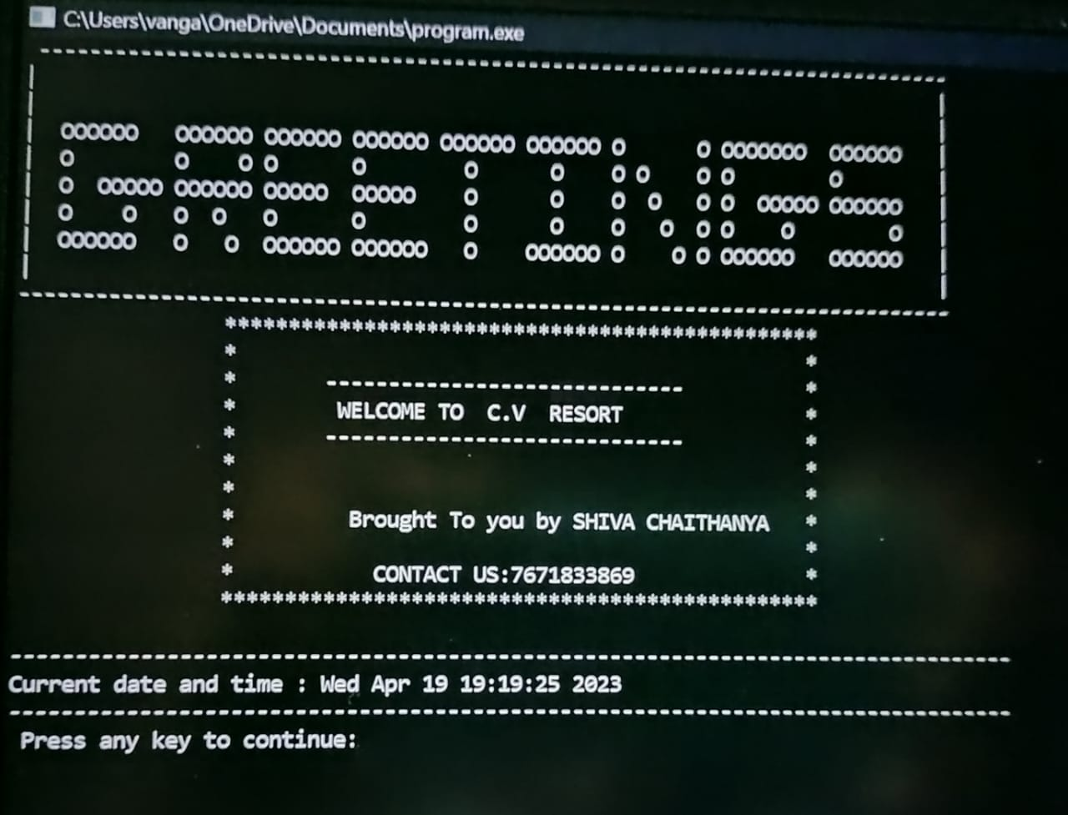
LOGIN SCREEN WINDOW:
When you start the project from any compiler or by double-clicking the executable.exe file, you’ll see the screen shown below is login screen window.
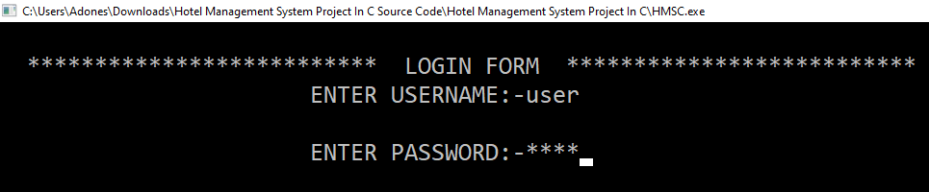
MENU SCREEN WINDOW:

The menu function is used to display a menu where a user may do various operations, which are discussed in more detail below.
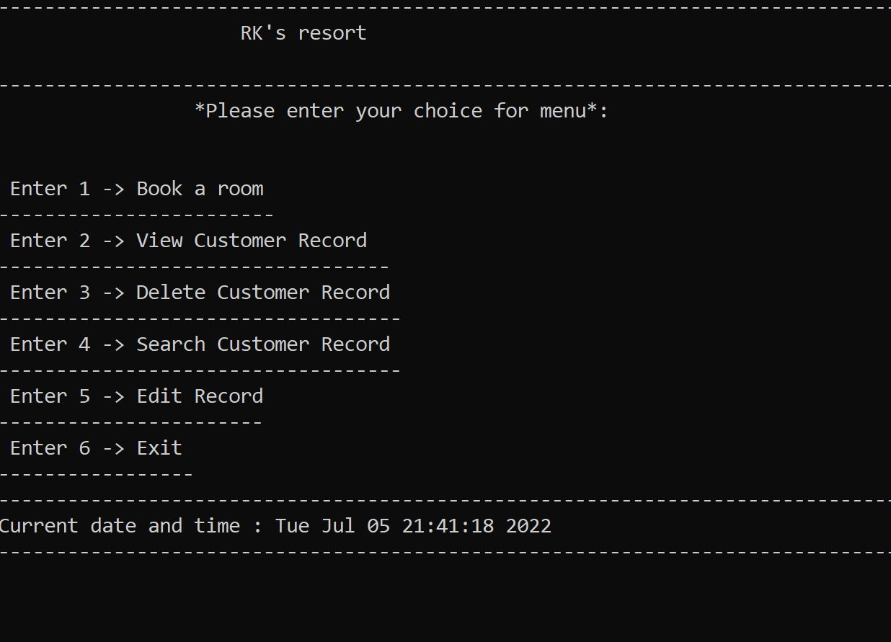
BOOK A ROOM:

The BOOK A ROOM function is used to create a new booking for the customer, which records information such as the room number, name, address, phone number, nationality, email, period of days, arrival date,

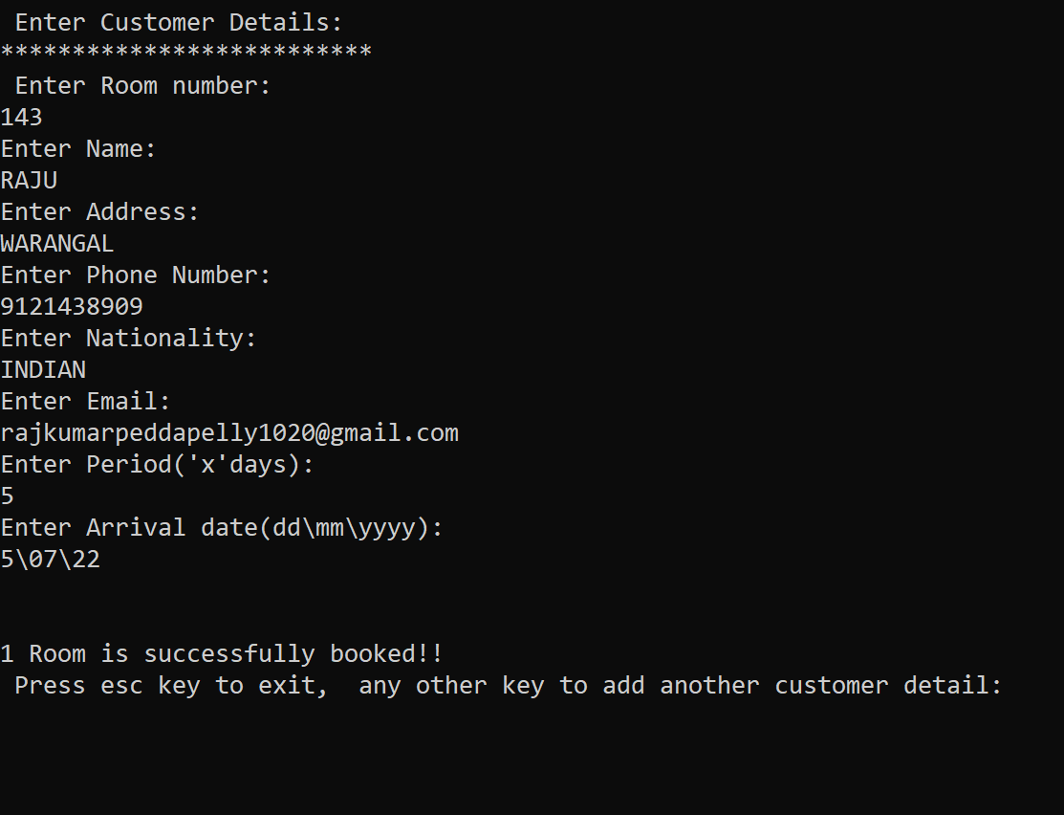

VIEW CUSTOMER RECORD:

The VIEW CUSTOMER RECORD function is used to view customer record information.
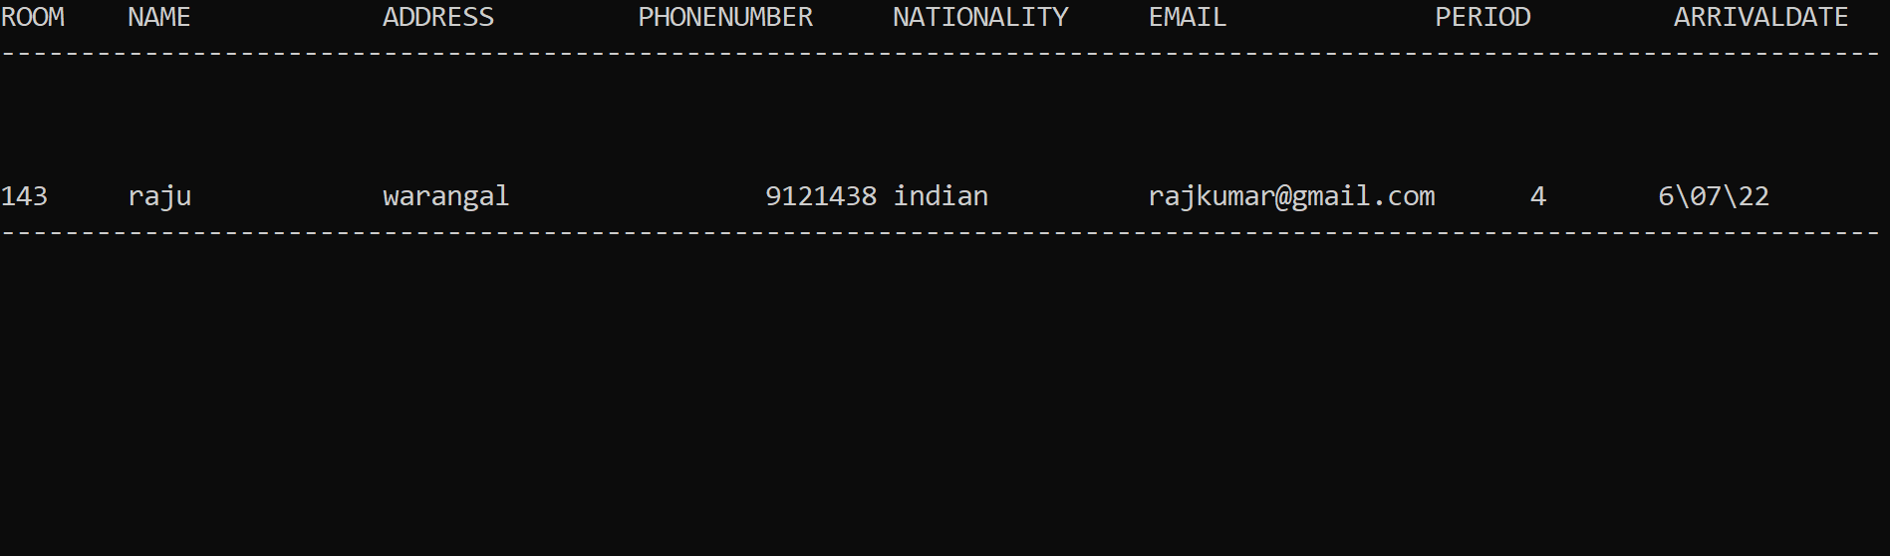
DELETE CUSTOMER RECORD:
The DELETE CUSTOMER RECORD function is used to delete customer record information.
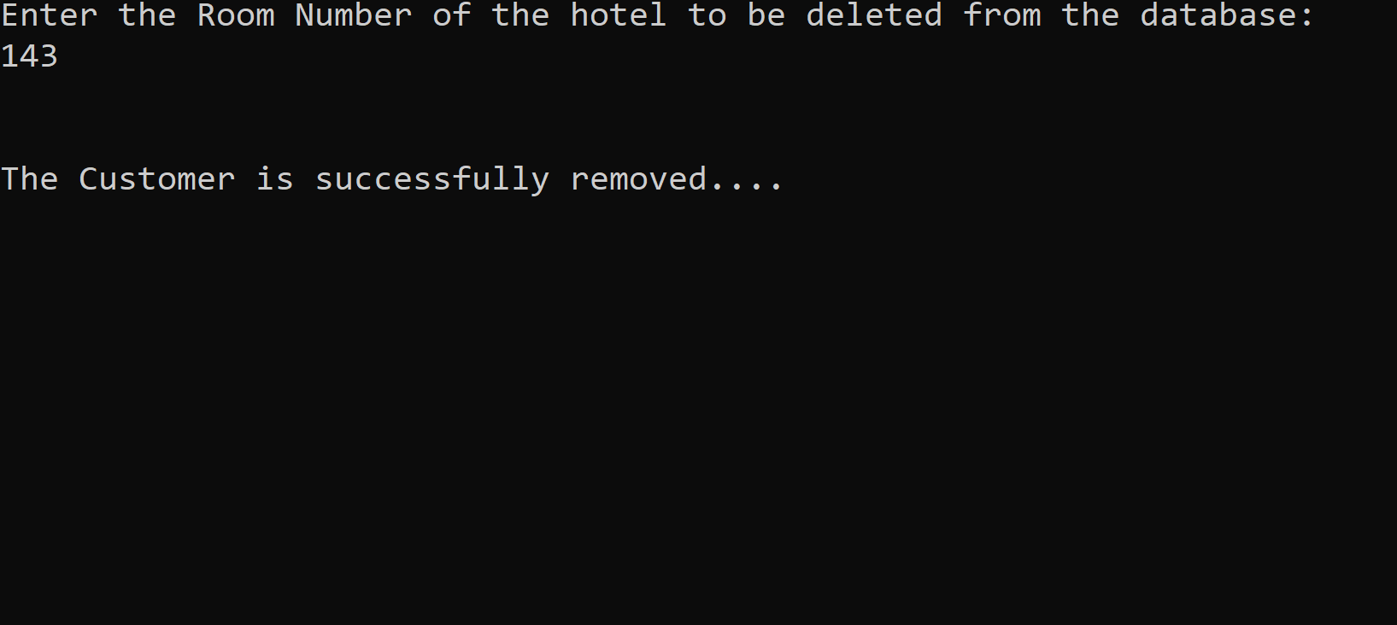

SEARCH CUSTOMER RECORD:

The SEARCH CUSTOMER RECORD function is used to search customer record information.
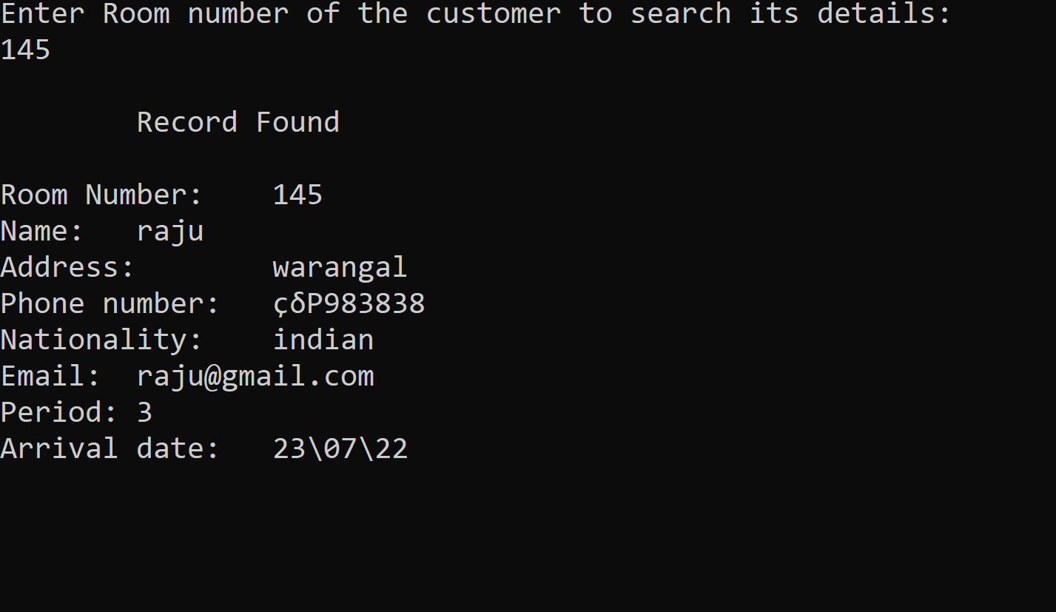
EDIT RECORD
The EDIT CUSTOMER RECORD function is used to update customer record information.
